Security items available from
The Wiltshire Bobby Van Trust and Community Affairs Office, Salisbury

Mouse Alarm - £4.00  Novelty alarm popular with children.  Comes with batteries.  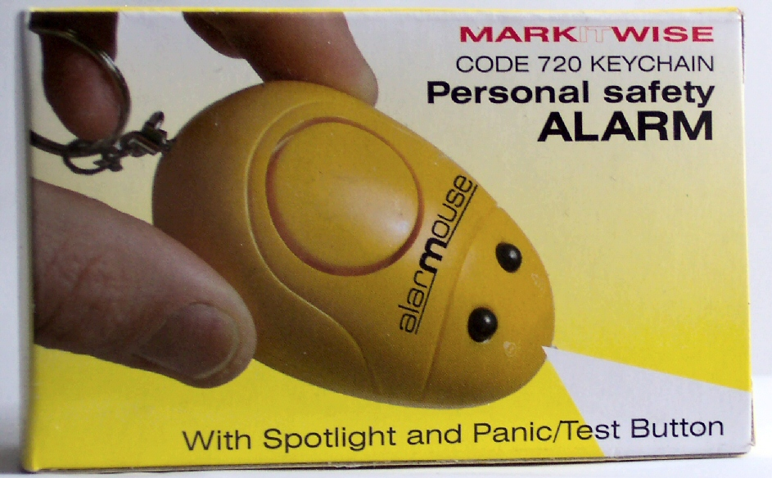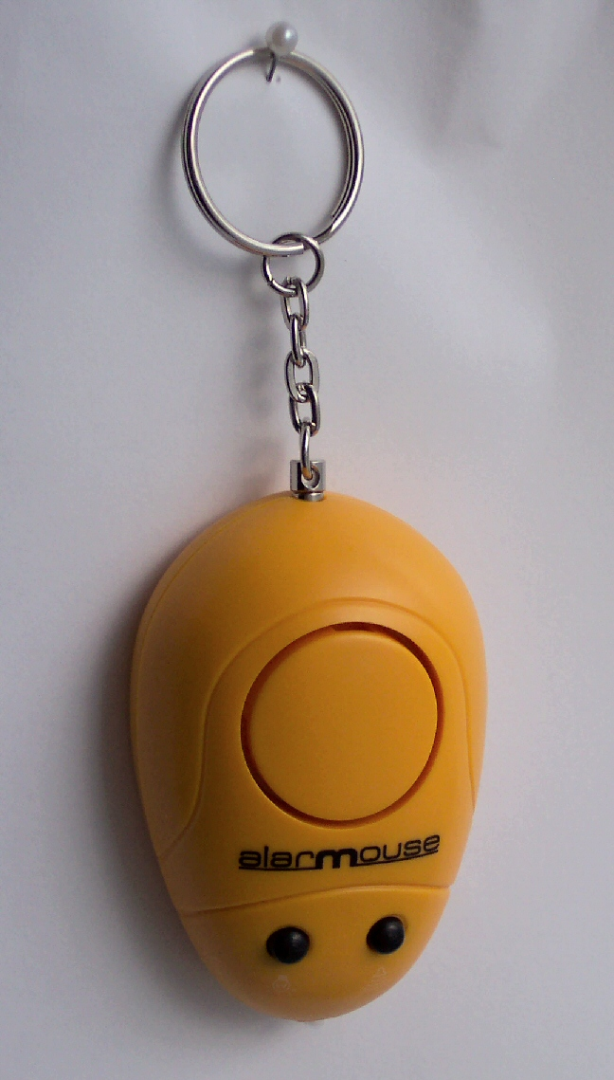 | Personal Wrist Alarm - £6.00  Useful for dog walkers and joggers.  Comes with batteries.  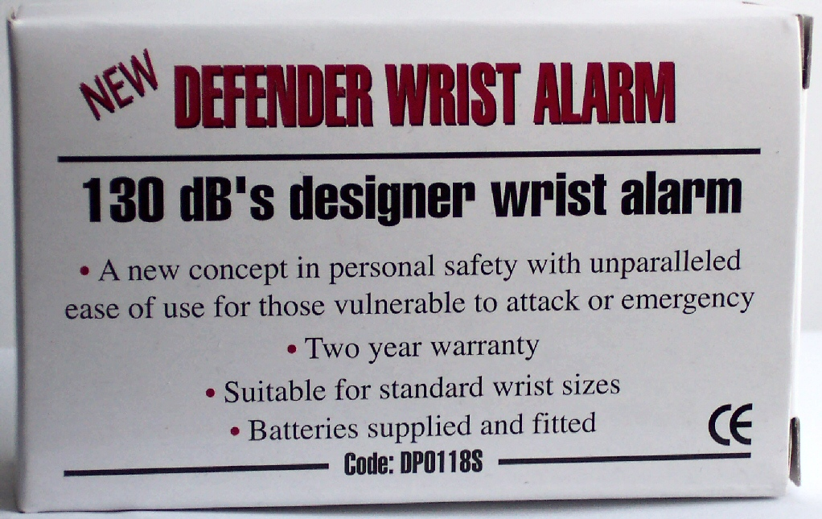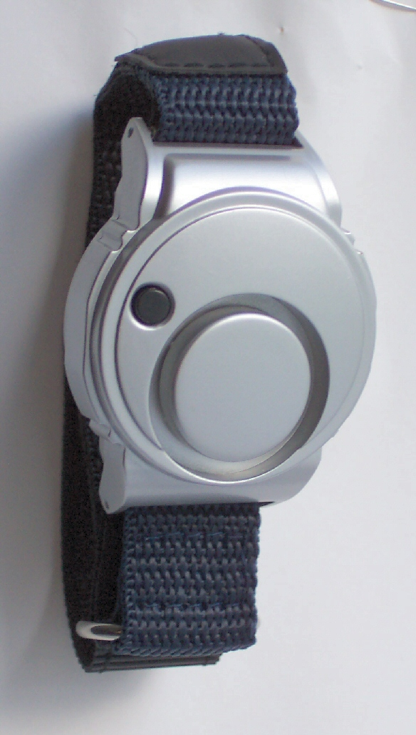
Personal Alarm - £6.00  Our loudest alarm. Good for handbags  and doors. Comes with batteries.  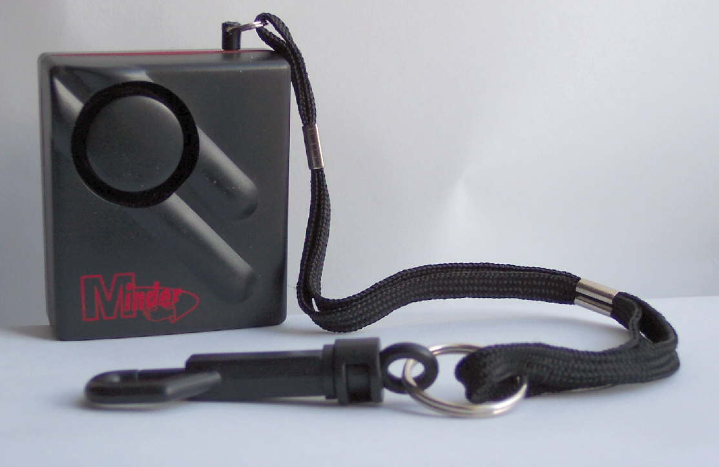 | Key cord - £1.00  Use the sticky pad to place keys where  they can be found in an emergency.  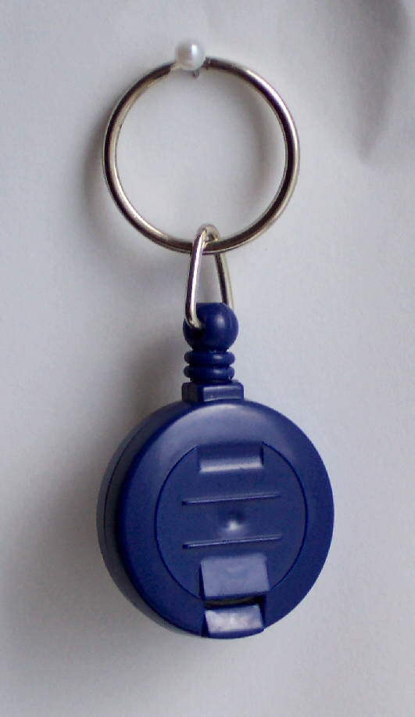
Mini House Alarm £16.00  With remote control. Good for sheds and garages. Comes with batteries.  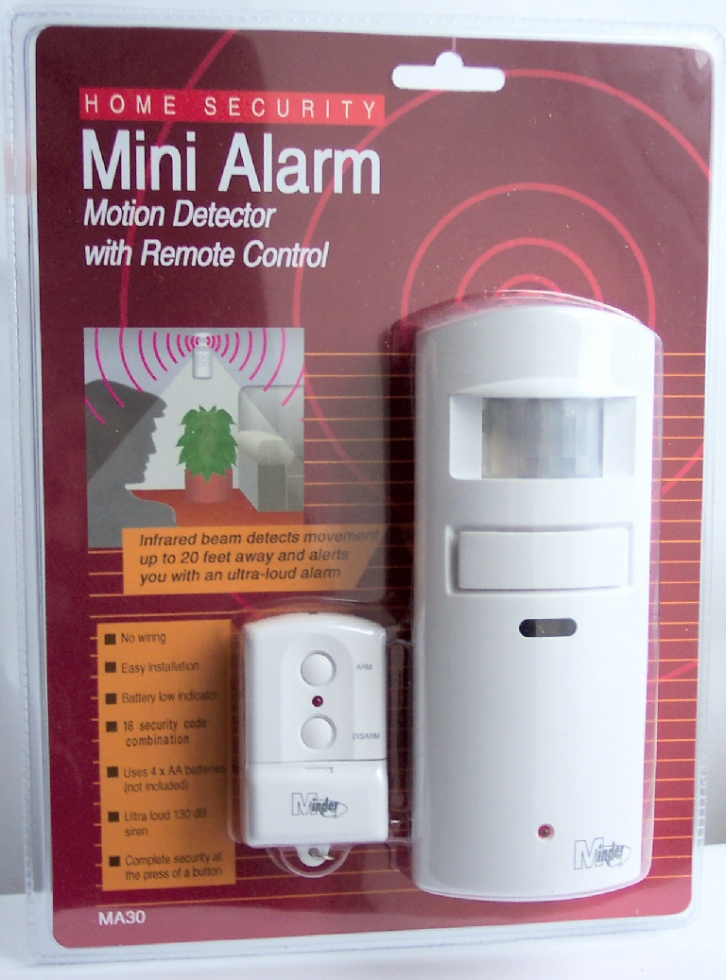 | Key Turner - £7.00  Very useful to those who find it  difficult to hold or turn keys.  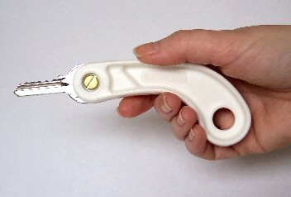

More overleaf…

Safe Can - £3.00  For hiding small items.  Not recommended for your life savings!   | Safe Book - £6.00  For hiding small items.  Not recommended for your life savings!  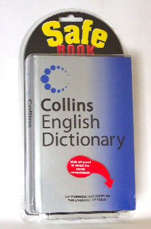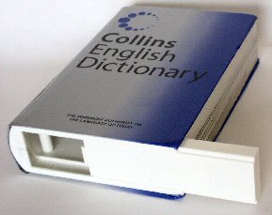
Property Marking Kit - £8.00  UV marker pen and UV torch to check  markings on your belongings.  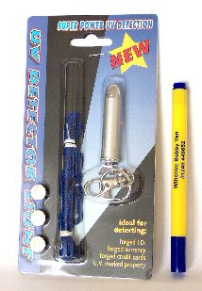 | All the security items on this  sheet may be purchased  from our office, or a Bobby Van.

The Wiltshire Bobby Van Trust
Chippenham Police Station
Wood Lane
CHIPPENHAM
Wiltshire
SN15 3DH

Tel: 01249 449 652

