Bulletin Number: 10 | Date: 20th October 2010

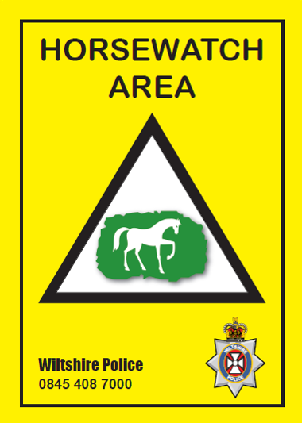
Hello and welcome..... What’s new?

HW Signs for Wiltshire.....

Signs are A4 size, and made from Flexi plastic, which makes them long lasting and versatile! Signs can be nailed direct to wood or holes made and attached to gate or fence, using plastic ties!
Please contact me for availability....a small donation to cover production cost only!
TEXT ALERTS
The “Rural Crime Team” also coordinates “Farmwatch” and we feel that a lot of the issues that affect farmers also affect you.....
So with that in mind, it is hoped that all appropriate Text Alerts, are sent to both Watch Schemes from now on!

www.necd.org.uk

The database went “live” on the 1st August and the official launch was on the 16th September. Representatives of the equine press, veterinary profession, police and Horsewatch schemes, a leading equine insurance company, leading equine charities, known equine personalities, attended the launch.
The database is designed to help the equine community protect their property, get it returned if the unfortunate happens and it is stolen but later found.
The front page of the web site now has a 4-minute introductory video, which explains to the viewer what NECD is all about.

NECD is currently offering an annual membership to the scheme for £10 instead of the standard price of £35. This offer will last until 31st October 2010.

WILTSHIRE HORSEWATCH MEMBERS
Enter Promo code below when making payment
NECDWILTSHW

The scheme works on the basis that registered property entered into the data base must be uniquely identifiable i.e. post code, serial number, micro chip number, freeze mark…………
This aligns to the Horsewatch recommendation that all property should be uniquely marked to help identify its owner.

“You expect me to do what??!!!”

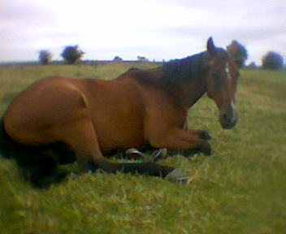


http://www.facebook.com/pages/Marlborough-United-Kingdom/Wiltshire-Horsewatch/124761100905641
To date, 265 people have clicked the “Like” button! This is fantastic.....
Wiltshire Horsewatch promotes the sharing of information within our equine community. It offers Crime Prevention advice, real time news and information.
HIGH VIZ
It’s that time of year when daylight disappears fast....... anyone who follows our “Facebook” page, will know that a number of accidents have been reported to us relating to RTC’s and equines, resulting in injury to equines and persons!
Car / Van versus Equine...... a scary scenario!! Please wear your HIGH VIZ clothing....


EQUESTRIAN

Theft of saddles has risen sharply over the last few months with many livery yards being cleaned out overnight by increasingly audacious thieves.
Datatag provides a simple to fit electronic "finger print" for your saddle together with a warning decal for the tack room.
Unlike some similar systems on the market Datatag uses a transponder that is resistant to the crush and shear that occurs in a saddle and benefits from the comprehensive infrastructure of Police scanners to support the Datatag system.

Datatag is easy to fit at home with the special tool included in the kit or can be installed by your saddler.
Datatag also has a system available to manufacturers for horsebox trailers. Various manufacturers already offer Datatag as standard such as Ifor Williams, Fautras, Rice, Wessex and Pegasus and is an optional extra with Indespension and Brian James.

 |  | 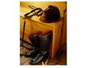 | 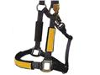

www.datatag.co.uk
DATATAG LAUNCHES NEW TRAILER THEFT DETERRENT SYSTEM AND INSURANCE INITIATIVE

Datatag ID Ltd the market leader in electronic theft deterrent systems has for many years supplied major trailer manufacturers with their security system fitted during production.
Datatag's strategy of constant development utilizing the latest - state of the art ID technology has seen the development of a new system which caters for new and retrospective fitment to trailers. The Datatag trailer system uses a multi layered security approach including new high visibility tamper proof ID plates, Datatag RFID technology or electronic tags, hundreds of microscopic Datadots® and even a new Forensic Chemical DNA, known as DataDNA. Datatag systems and technologies are proven as a powerful theft deterrent and are now used by the official CESAR Scheme supported by the Home Office and ACPO (Construction Equipment Security and Registration Scheme)
In conjunction with a National Insurer, Datatag can now offer trailer insurance to any type of trailer including box, flat-bed, transport, tipping or horse trailer and the key benefits include
The Most Competitive Premiums
Plus a generous 20% discount if Datatag theft deterrent system fitted
New for Old cover for new trailers
Cover includes European Use and Replacement Hire

www.cesarscheme.org

Reminder
Any changes to your email address or Mobile number
Please inform ASAP!
Stay safe – Think secure
PCSO John Bordiss – Mobile 07968942116

